CALL FOR ARTICLE IN THE BOOK
“contributions to statistical development in honour of PROFESSOR BIYI afonja’’
Deadline: November 20
The Effects of COVID-19 Pandemic on Food Prices: A Nigerian Experience

¹Serifat A. Folorunso, ² Babatunde Adebayo, ³Saheed A. Afolabi
¹serifatf005@gmail.com,²adebayo.bt11@gnail.com &afsab4ever@yahoo.com

¹³University of Ibadan laboratory for Interdisciplinary Statistical Analysis (UI-LISA), Ibadan, Nigeria.
²Jumia Nigeria and University of Ibadan laboratory for Interdisciplinary Statistical Analysis (UI-LISA), Ibadan, Nigeria.

ABSTRACT
The study evaluates the effect of COVID -19 pandemic on food prices in Nigeria. It is based on the application of some statistical tools like regression analysis and correlation analysis. The study explores three in one data visualisation that is showing the effect of COVID-19 on Food Prices in Nigeria. The common food items are Beans, Beef, Bread, Catfish, Egg, Frozen Chicken, Garri, Irish potato, local rice, Maize, Plantain, Imported rice,…., Yam tuber among others. Their prices are viewed with gray for prices before COVID-19 and pale red for prices during COVID-19. It is revealed from the Data Visualization that the stable food prices is less and affordable for Nigerian before the Pandemic but there is hike in the food items during COVID-19 pandemic as a result of Lockdown. The data visualisation also reveals total confirmed cases in Africa and Nigeria. The figure depict that there have been 1 548 475 cases having Nigeria to be one of the five countries with highest cases of more than fifty thousand. Lagos state is viewed to have the highest cases in Nigeria.
Keywords: Correlation, Data Visualisation, Lockdown, Regression, Staple food

- Introduction.
In Nigeria, the COVID-19 pandemic is part of the 2019 global coronavirus disease pandemic caused by severe acute respiratory syndrome coronavirus 2 (SARS-CoV-2). The Federal Ministry of Health has confirmed the first case to be reported in Nigeria on February 27, 2020, when an Italian citizen in Lagos was tested positive since the beginning of the outbreak in China in January 2020. There has been several new confirmed cases recorded in Nigeria recently with about 65,457 cases where 61,337 cases have been discharged and 1,163 deaths as at November 17, 2020 in the 36 states and the Federal Capital Territory. The waves is still on the increase.

The Federal Government of Nigeria, through the PTF-COVID-19, along with the Federal Ministry of Health, has introduced several measures to curb the spread of the disease and protect the health of Nigerians. This includes the initial lockdown of non-essential activities; the closing of schools; the banning of foreign flights, etc. Nigeria is one of many countries that initially initiated the gradual easing of lockdown steps at the beginning of the COVID-19 pandemic. All these efforts were led by the Nigeria Centre for Disease Control (NCDC) and works closely with all states of the Federation to support their pandemic response activities.

Most health analysts predict that this virus will continue to circulate for a least one or two more years (Scudellari, 2020). Following the imposition of the lockdown on 1 April 2020 in the states of Lagos, FCT and Ogun, the Federal Ministry of Disaster Management and Social Development for Humanitarian Affairs declared that it would provide food rations to vulnerable households in those states. In several regions of the world, the prolonged lockdown has led to individuals facing hunger and many witnessed not only a major disruption to food supply chains in the wake of lockdowns. The effect of lockdown have resulted in lower incomes and higher prices of some foods, putting food out of reach for many, and undermining the right to food and stalling efforts to meet Sustainable Development Goal (SDG) 2: “Zero hunger.” (Ghebreyesus, 2020; Khorsandi, 2020). In localised contexts, the Covid -19 pandemic culminated in inconsistent food prices (see, for example, Klassen and Murphy, 2020; Clapp and Moseley, 2020; Laborde et al., 2020).

According to Lewis, 2020; & Terazono and Munshi, 2020, they opined that the closure of restaurants and other food service facilities has led to a sharp drop in demand for certain perishable foods, including dairy products, potatoes and fresh fruits, as well as specialty products such as chocolate and certain high-value meat cuts.

Some food exporting countries have placed export restrictions on main staple food products such as rice and wheat in the early months of the outbreak of COVID-19, leading to some disturbances in the global movement of these staples as well as higher prices of these crops compared to others (Laborde et al., 2020).

In Nigeria, over the entire pandemic period, the consumer price index for food has risen. It increased from 14.9 percent in February 2020 to 15.18 percent in June 2020, showing a rise in just four months of around 0.28 percent. The absurd situation for Nigeria was that the rise in food prices varied across the country. The hit of food price inflation was felt toughest by some states. Prices rose year on year in Sokoto (Northwest Nigeria) by 17.12 percent, in Plateau (North Central) by 16.99 percent, in Gombe (Northeast) by 16.96 percent, in Edo (South-South) by 16.71 percent, and in Kano (Northwest) by 16.45 percent, they mostly the major food producing region.

Corn, cowpeas, groundnuts, garlic, wheat, sugarcane, pepper, onions and tomatoes are the major producers in Sokoto. In the Plateau state, groundnut, sorghum, sesame seed, maize, potatoes, tomatoes, onions and pepper are predominantly cultivated. For groundnuts, ginger, cowpea, sesame seeds, tomatoes and pepper are well known in Gombe. In Edo State, plantain, oil palm and cassava are primarily grown. Kano also grows rice, garlic, sorghum, cowpea, maize, pepper, onions and tomatoes in large quantities. The Abuja chapter of the International Committee of the Red Cross (ICRC) announced that Kano, the main seed producer in Nigeria, was among the areas hardest hit by the pandemic during the planting season, which affected seed processing. In the early months of the outbreak of COVID-19, some food exporting countries also imposed export restrictions on key staple food items like rice and wheat, which led to some disruptions in the global movement of these staples as well as higher prices of these crops relative to others (Laborde et al., 2020).

The price of food products such as beans, pepper, palm oil, onions, tomatoes, garri, and potatoes has increased significantly, according to the latest survey by Nairametrics. For example, for an average a big bag of pepper which is currently sold at N15, 000 compared to the N7, 000 pre-lockdown price, which implies an increase of 114.3 %. Similarly, as it currently sells for an average of N17, 000, the price of a big bag of dry onions spiked by 30.77 %. A basket of sweet potatoes sells for an average of N15, 000 in the same vein, indicating a 150 % increase compared to N6, 000 pre-lockdown prices.
From this study the impact of Covid19 on food prices in Nigeria will be determine and analyse using the three Dimension data visualisation and using some exploratory data analysis. The major objectives is to analyse the impact of Covid19 on some food prices in Nigeria. The rest of the paper is divided as follows. Section 2 gives the data presentation and data visualisation Section 3 describes the methodology Section 4 analyses the data. Section 5 discusses the results and findings. Finally, the last part presents the conclusion.

2 Data Presentation and Data Visualisation Mr Babatunde
2.1 Data Description
2.2 Data Visualization
Cumulative Number of Confirmed COVID-19 Cases by Geopolitical Regions
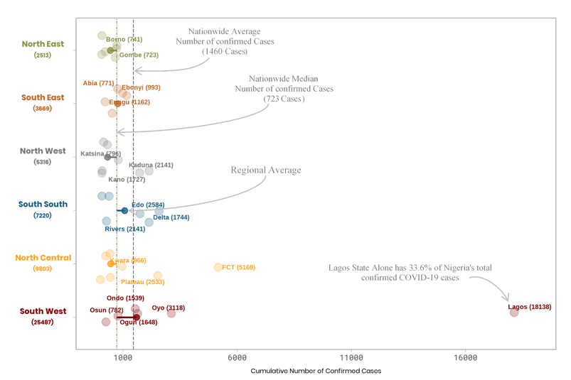
Figure 1: Cumulative Number of Covid-19 Confirmed Cases by Geopolitical Zone (as at August 31st 2020)
Cumulative number of confirmed cases in five states from south west region (Lagos, Oyo, Ogun, Ondo, Osun and Ondo), four states from North Central (FCT, Plateau and Kwara) exceed the nationwide median cumulative of 723 cases.

Time Plot of National Average of Food Prices
(January 2019 to August 2020)
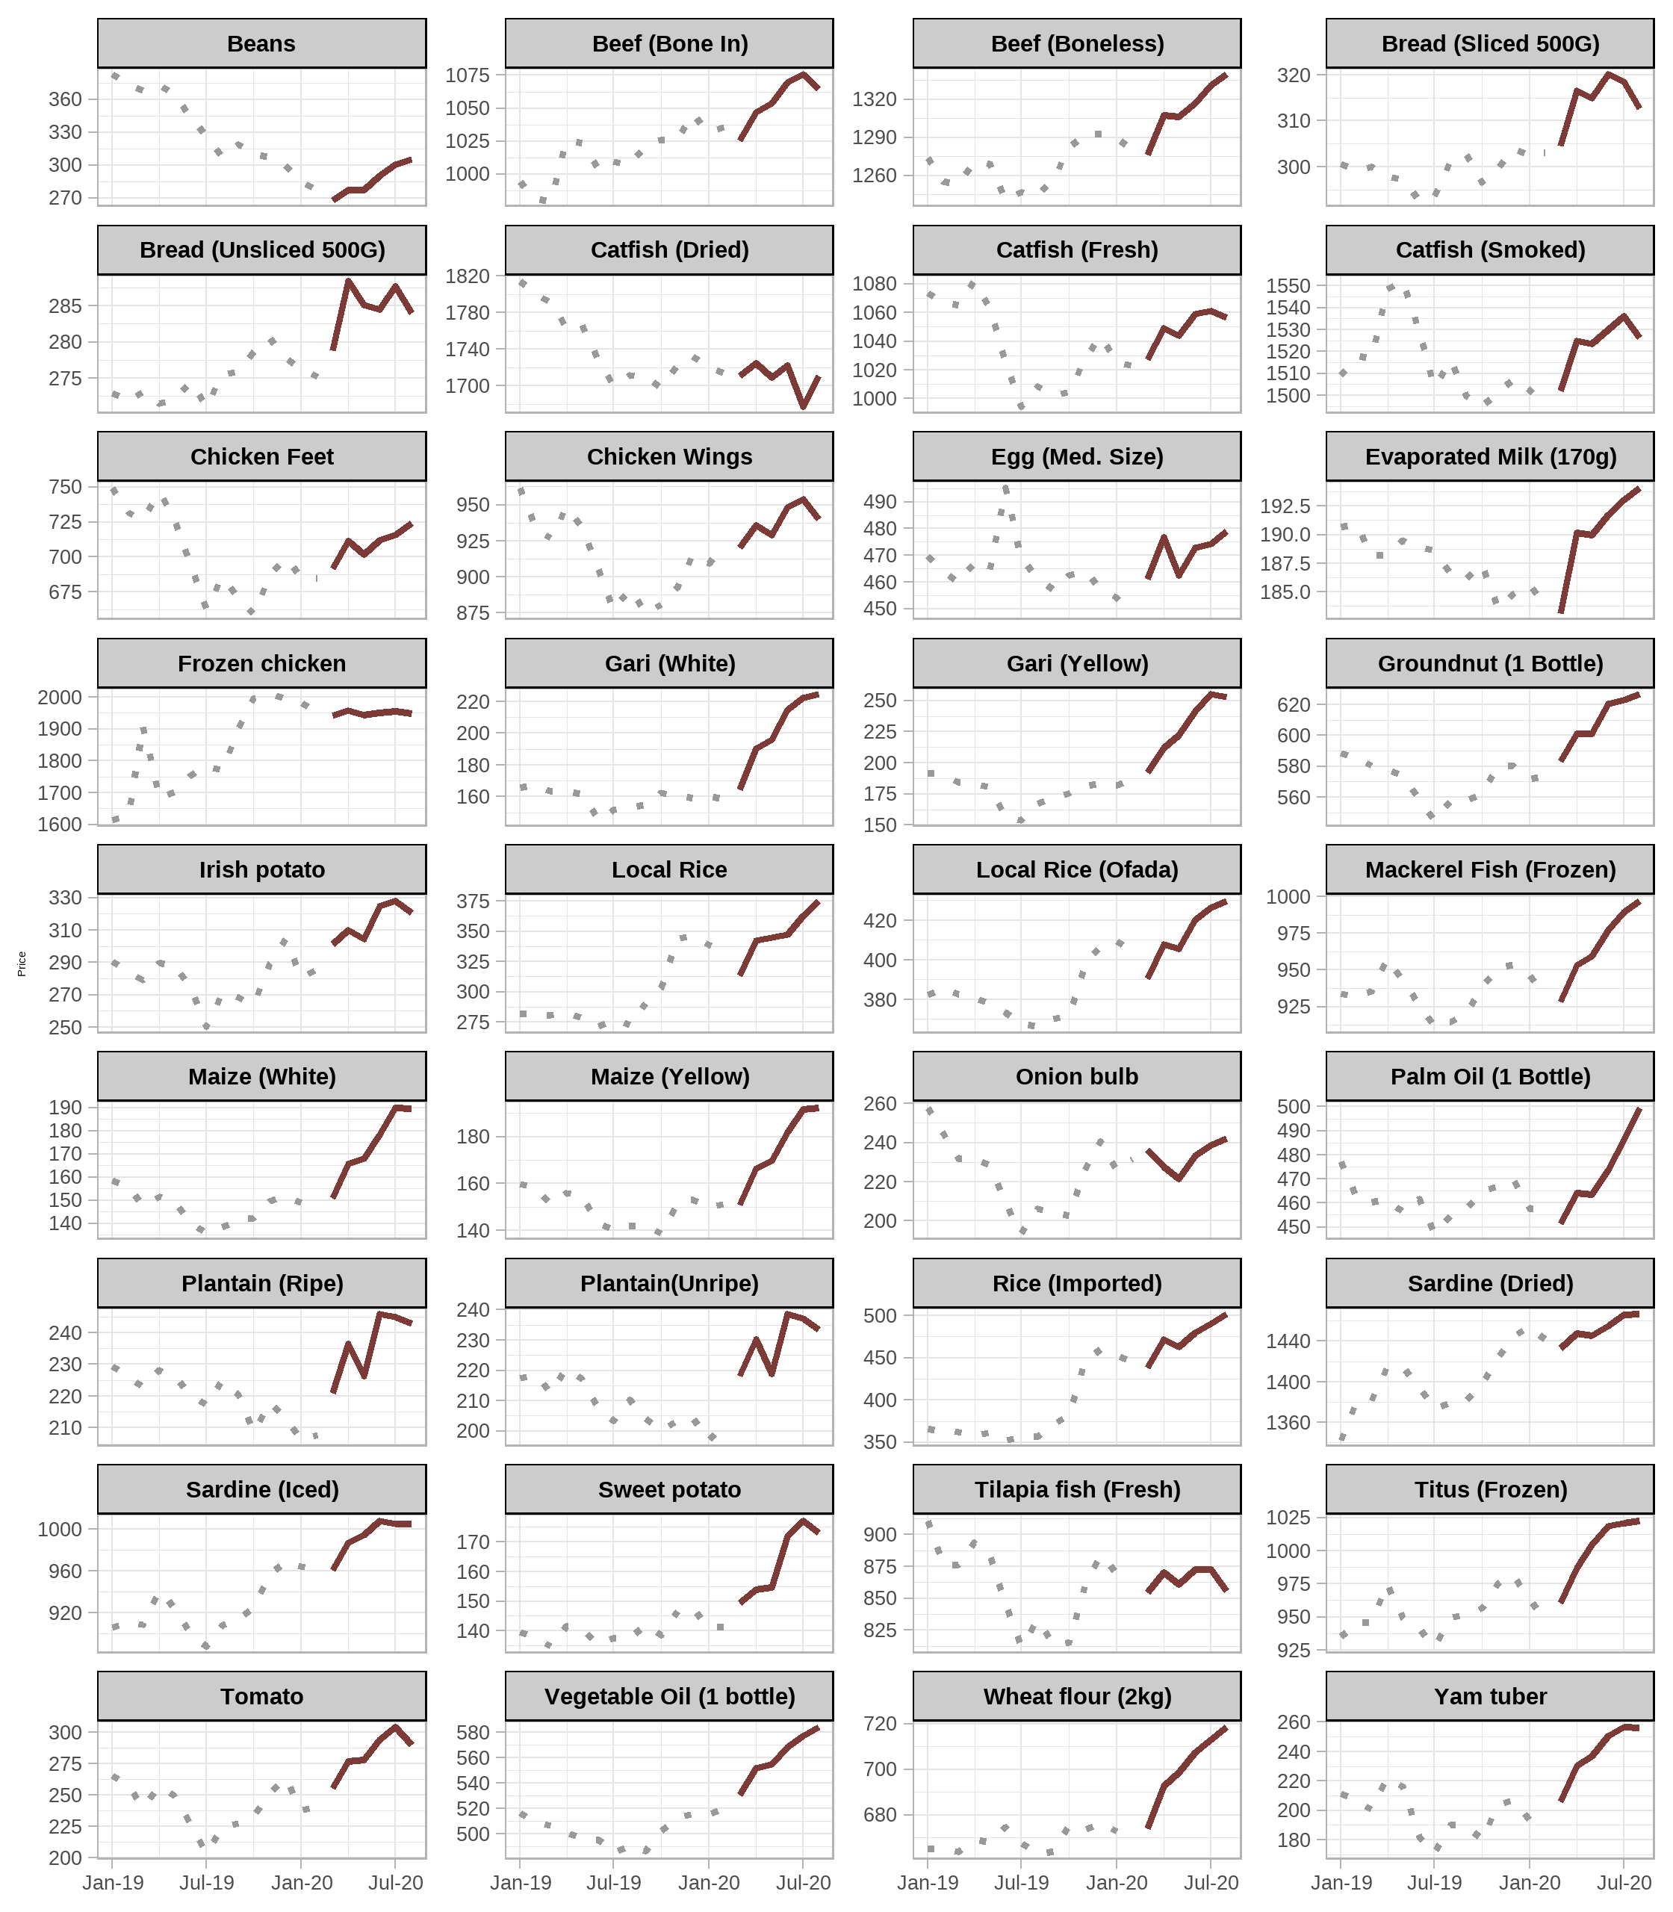
Figure 2: Time plot of price of food items between January 2019 and August 31st 2020). Prices before COVID-19 are in dotted gray lines while prices during COVID-19 pandemic are in pale red color thick lines.
3. Methodology
3.1 Exploratory Data Analysis
Minimum
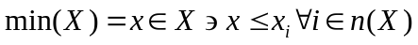 (1)
Maximum
 (2)
Mean
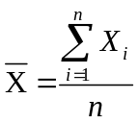 (3)
Standard Deviation
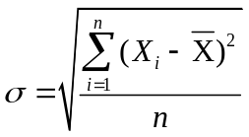 (4)
Skewness
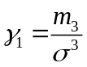 (5)
where 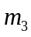 is the third-order moment of the data given by:
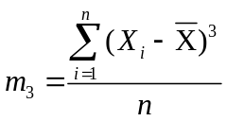 (6)
And  is the arithmetic mean, n is the number of total observation and 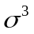 is the standard deviation raised to the third power with X being the pollutant of interest.
Kurtosis
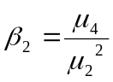 (7)

3.3 Testing the Significant Difference using T- Test
It is used to test if there is a significant difference between two population means.
3.3.1 Paired Samples T-Test
Test for Difference of Means
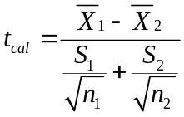 (8)
where S.E = with pool variance s² = 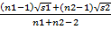 (9)

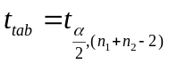 (10)

4.0 Data Analysis

Table 1: Descriptive Statistics of Food Items’ Prices before COVID-19
Food Items | Minimum | Maximum | Mean | Std. Deviation | Skew. | Kurtosis
Agric_eggs_medium_size | 454.17 | 468.31 | 460.77 | 4.81 | 0.20 | -0.56
Agric_eggs_medium_size_price_of_one | 38.38 | 41.30 | 40.40 | 0.97 | -1.79 | 3.83
Beans_brown_sold_loose | 285.61 | 327.18 | 307.82 | 13.32 | -0.29 | 0.60
Beans_white_black_eye_sold_loose | 268.80 | 292.00 | 282.32 | 8.41 | -0.68 | -0.63
Beef_Bone_in | 1007.39 | 1045.86 | 1024.03 | 13.09 | 0.34 | 0.15
Beef_boneless | 1244.23 | 1293.00 | 1272.22 | 21.93 | -0.40 | -2.30
Bread_sliced_500g | 293.49 | 304.06 | 300.01 | 3.77 | -0.95 | -0.10
Bread_unsliced_500g | 271.02 | 280.51 | 276.50 | 3.00 | -0.78 | 1.42
Broken_Rice_Ofada | 366.22 | 409.31 | 384.14 | 19.39 | 0.48 | -2.31
Catfish_obokun_fresh | 994.21 | 1043.41 | 1015.11 | 17.41 | 0.58 | -0.78
Catfish_dried | 1697.55 | 1732.45 | 1713.74 | 12.53 | 0.13 | -1.00
Catfish_Smoked | 1494.81 | 1515.95 | 1503.69 | 6.66 | 0.88 | 1.54
Chicken_Feet | 659.60 | 699.06 | 678.63 | 14.40 | -0.11 | -1.31
Chicken_Wings | 874.72 | 915.62 | 891.79 | 15.82 | 0.56 | -1.21
Dried_Fish_Sardine | 1373.11 | 1454.59 | 1407.84 | 33.16 | 0.47 | -1.80
Evaporated_tinned_milk_carnation_170g | 156.98 | 159.61 | 157.92 | 1.16 | 1.00 | -1.15
Evaporated_tinned_milk_peak_170g | 183.56 | 188.59 | 186.11 | 1.66 | -0.06 | -0.15
Frozen_chicken | 1770.45 | 2008.39 | 1919.51 | 103.56 | -0.85 | -1.42
Gari_white_sold_loose | 151.73 | 162.42 | 157.41 | 3.92 | -0.31 | -1.57
Gari_yellow_sold_loose | 154.05 | 183.26 | 173.71 | 10.44 | -1.22 | 1.20
Groundnut_oil_1_bottle_specify_bottle | 545.13 | 580.45 | 565.01 | 13.08 | -0.14 | -1.05
Iced_Sardine | 887.69 | 969.60 | 932.09 | 31.69 | -0.05 | -1.79
Irish_potato | 250.34 | 304.46 | 275.64 | 17.71 | 0.36 | 0.08
Mackerel_frozen | 911.43 | 953.29 | 933.79 | 17.74 | -0.21 | -2.20
Maize_grain_white_sold_loose | 135.76 | 151.88 | 144.06 | 6.14 | -0.02 | -1.75
Maize_grain_yellow_sold_loose | 138.74 | 153.00 | 145.33 | 5.90 | 0.33 | -2.22
Mudfish_aro_fresh | 971.74 | 1010.99 | 989.02 | 15.26 | 0.43 | -1.92
Mudfish_dried | 1741.27 | 1774.96 | 1760.84 | 10.58 | -0.86 | 1.67
Onion_bulb | 193.56 | 240.55 | 214.07 | 16.86 | 0.50 | -1.12
Palm_oil_1_bottle_specify_bottle | 447.40 | 469.43 | 459.74 | 7.73 | -0.32 | -0.69
Plantain_ripe | 206.17 | 225.04 | 215.51 | 6.63 | -0.12 | -0.89
Plantain_unripe | 197.06 | 210.27 | 203.24 | 4.07 | 0.28 | 1.42
Rice_agric_sold_loose | 310.03 | 390.18 | 349.06 | 35.43 | 0.15 | -2.49
Rice_local_sold_loose | 272.77 | 345.94 | 310.36 | 32.01 | 0.06 | -2.35
Rice_Medium_Grained | 305.93 | 381.68 | 346.14 | 34.06 | 0.00 | -2.33
Rice_imported_high_quality_sold_loose | 356.10 | 459.90 | 403.57 | 47.16 | 0.27 | -2.53
Sweet_potato | 137.48 | 147.46 | 141.55 | 4.13 | 0.59 | -1.42
Tilapia_fish_epiya_fresh | 812.22 | 884.07 | 841.21 | 29.82 | 0.40 | -1.91
Titus_frozen | 927.61 | 981.21 | 957.90 | 17.81 | -0.43 | 0.34
Tomato | 203.55 | 263.90 | 234.37 | 19.46 | -0.01 | 0.32
Vegetable_oil_1_bottle_specify_bottle | 485.05 | 516.29 | 501.43 | 13.68 | -0.10 | -2.34
Wheat_flour_prepacked_golden_penny_2kg | 663.26 | 676.20 | 670.43 | 5.33 | -0.46 | -1.84
Yam_tuber | 170.85 | 206.82 | 190.56 | 12.49 | -0.31 | -0.41
DNC | 0.00 | 0.00 | 0.00 | 0.00 | . | .
DD | 0.00 | 0.00 | 0.00 | 0.00 | . | .

Table 2: Descriptive Statistics of Food Items’ Prices during COVID-19
Food Items | Minimum | Maximum | Mean | Std. Deviation | Skew. | Kurtosis
Agric_eggs_medium_size | 448.26 | 478.97 | 467.79 | 10.98 | -0.95 | 0.12
Agric_eggs_medium_size_price_of_one | 39.29 | 42.78 | 41.28 | 1.33 | -0.49 | -1.34
Beans_brown_sold_loose | 267.81 | 305.43 | 284.89 | 13.94 | 0.51 | -1.29
Beans_white_black_eye_sold_loose | 241.74 | 274.80 | 257.33 | 11.27 | 0.38 | -0.47
Beef_Bone_in | 1025.48 | 1075.68 | 1053.04 | 18.39 | -0.33 | -1.18
Beef_boneless | 1276.10 | 1339.74 | 1308.21 | 23.93 | -0.22 | -1.15
Bread_sliced_500g | 303.06 | 320.10 | 312.94 | 6.67 | -0.74 | -1.12
Bread_unsliced_500g | 275.20 | 288.45 | 283.40 | 4.79 | -0.92 | -0.07
Broken_Rice_Ofada | 390.54 | 429.81 | 412.14 | 13.96 | -0.17 | -0.89
Catfish_obokun_fresh | 1022.84 | 1061.25 | 1045.70 | 15.32 | -0.70 | -1.24
Catfish_dried | 1677.22 | 1724.52 | 1709.85 | 15.54 | -1.85 | 4.24
Catfish_Smoked | 1496.07 | 1536.03 | 1519.76 | 14.86 | -0.94 | -0.63
Chicken_Feet | 684.50 | 724.19 | 705.96 | 14.05 | -0.46 | -0.89
Chicken_Wings | 920.52 | 953.89 | 935.73 | 12.61 | 0.22 | -1.35
Dried_Fish_Sardine | 1432.95 | 1466.66 | 1450.72 | 12.67 | 0.12 | -1.21
Evaporated_tinned_milk_carnation_170g | 150.54 | 163.74 | 159.27 | 5.15 | -1.19 | -0.31
Evaporated_tinned_milk_peak_170g | 183.12 | 194.11 | 189.42 | 4.33 | -0.76 | -1.08
Frozen_chicken | 1941.04 | 1958.10 | 1949.49 | 5.91 | 0.15 | -0.63
Gari_white_sold_loose | 159.33 | 224.53 | 196.01 | 26.55 | -0.40 | -1.59
Gari_yellow_sold_loose | 186.35 | 255.10 | 223.22 | 27.93 | -0.17 | -1.80
Groundnut_oil_1_bottle_specify_bottle | 572.36 | 626.69 | 603.98 | 20.80 | -0.46 | -1.27
Iced_Sardine | 960.69 | 1008.23 | 988.96 | 20.51 | -0.75 | -1.39
Irish_potato | 286.21 | 328.07 | 310.75 | 14.85 | -0.50 | -0.50
Mackerel_frozen | 928.27 | 997.01 | 962.33 | 26.81 | -0.03 | -1.60
Maize_grain_white_sold_loose | 150.15 | 190.00 | 170.35 | 16.50 | -0.04 | -1.61
Maize_grain_yellow_sold_loose | 150.97 | 192.43 | 172.09 | 17.32 | -0.07 | -1.74
Mudfish_aro_fresh | 991.44 | 1009.02 | 1000.47 | 6.67 | -0.27 | -1.56
Mudfish_dried | 1742.48 | 1764.13 | 1750.20 | 9.55 | 0.91 | -1.30
Onion_bulb | 221.40 | 241.97 | 232.97 | 6.95 | -0.53 | -0.09
Palm_oil_1_bottle_specify_bottle | 451.37 | 499.67 | 470.85 | 17.02 | 0.81 | -0.24
Plantain_ripe | 207.82 | 245.86 | 232.18 | 14.36 | -0.80 | -0.52
Plantain_unripe | 201.83 | 238.58 | 225.45 | 13.25 | -0.94 | 0.19
Rice_agric_sold_loose | 369.89 | 413.13 | 392.05 | 14.99 | -0.12 | -0.61
Rice_local_sold_loose | 313.10 | 375.08 | 345.74 | 19.89 | -0.18 | 0.52
Rice_Medium_Grained | 368.36 | 415.43 | 393.64 | 17.68 | -0.38 | -1.12
Rice_imported_high_quality_sold_loose | 438.66 | 501.71 | 469.95 | 23.18 | -0.13 | -1.17
Sweet_potato | 141.34 | 177.17 | 160.22 | 13.75 | 0.02 | -1.85
Tilapia_fish_epiya_fresh | 854.86 | 872.94 | 864.39 | 7.78 | -0.09 | -2.05
Titus_frozen | 948.14 | 1022.70 | 994.67 | 30.44 | -0.71 | -1.32
Tomato | 241.78 | 304.01 | 277.24 | 22.03 | -0.63 | -0.57
Vegetable_oil_1_bottle_specify_bottle | 520.95 | 583.76 | 555.38 | 23.24 | -0.38 | -1.14
Wheat_flour_prepacked_golden_penny_2kg | 668.01 | 718.39 | 695.98 | 19.13 | -0.49 | -1.25
Yam_tuber | 189.53 | 256.44 | 232.26 | 25.90 | -0.83 | -0.65
Dnc | 1.00 | 563.00 | 251.57 | 237.56 | 0.21 | -1.94
Dd | 0.00 | 10.00 | 4.57 | 4.16 | 0.17 | -1.96

Table 3: Test of Significance of Nigerian Food Prices Before and During COVID-19
 |  | t-value | df | Sig.  (2-tailed)
Pair 1 | D_Agric_eggs_medium_size - B_Agric_eggs_medium_size | 1.21 | 6 | 0.27
Pair 2 | D_Agric_eggs_medium_size_price_of_one - B_Agric_eggs_medium_size_price_of_one | 2.17 | 6 | 0.07
Pair 3 | D_Beans_brown_sold_loose - B_Beans_brown_sold_loose | -2.38 | 6 | 0.06
Pair 4 | D_Beans_white_black_eye_sold_loose - B_Beans_white_black_eye_sold_loose | -4.06 | 6 | 0.01
Pair 5 | D_Beef_Bone_in - B_Beef_Bone_in | 9.73 | 6 | 0.00
Pair 6 | D_Beef_boneless - B_Beef_boneless | 8.87 | 6 | 0.00
Pair 7 | D_Bread_sliced_500g - B_Bread_sliced_500g | 5.88 | 6 | 0.00
Pair 8 | D_Bread_unsliced_500g - B_Bread_unsliced_500g | 5.34 | 6 | 0.00
Pair 9 | D_Broken_Rice_Ofada - B_Broken_Rice_Ofada | 9.43 | 6 | 0.00
Pair 10 | D_Catfish_obokun_fresh - B_Catfish_obokun_fresh | 7.87 | 6 | 0.00
Pair 11 | D_Catfish_dried - B_Catfish_dried | -0.42 | 6 | 0.69
Pair 12 | D_Catfish_Smoked - B_Catfish_Smoked | 2.27 | 6 | 0.06
Pair 13 | D_Chicken_Feet - B_Chicken_Feet | 5.35 | 6 | 0.00
Pair 14 | D_Chicken_Wings - B_Chicken_Wings | 9.63 | 6 | 0.00
Pair 15 | D_Dried_Fish_Sardine - B_Dried_Fish_Sardine | 5.24 | 6 | 0.00
Pair 16 | D_Evaporated_tinned_milk_carnation_170g - B_Evaporated_tinned_milk_carnation_170g | 0.74 | 6 | 0.49
Pair 17 | D_Evaporated_tinned_milk_peak_170g - B_Evaporated_tinned_milk_peak_170g | 1.57 | 6 | 0.17
Pair 18 | D_Frozen_chicken - B_Frozen_chicken | 0.78 | 6 | 0.47
Pair 19 | D_Gari_white_sold_loose - B_Gari_white_sold_loose | 4.33 | 6 | 0.01
Pair 20 | D_Gari_yellow_sold_loose - B_Gari_yellow_sold_loose | 7.06 | 6 | 0.00
Pair 21 | D_Groundnut_oil_1_bottle_specify_bottle - B_Groundnut_oil_1_bottle_specify_bottle | 10.32 | 6 | 0.00
Pair 22 | D_Iced_Sardine - B_Iced_Sardine | 9.68 | 6 | 0.00
Pair 23 | D_Irish_potato - B_Irish_potato | 14.55 | 6 | 0.00
Pair 24 | D_Mackerel_frozen - B_Mackerel_frozen | 6.11 | 6 | 0.00
Pair 25 | D_Maize_grain_white_sold_loose - B_Maize_grain_white_sold_loose | 6.49 | 6 | 0.00
Pair 26 | D_Maize_grain_yellow_sold_loose - B_Maize_grain_yellow_sold_loose | 5.52 | 6 | 0.00
Pair 27 | D_Mudfish_aro_fresh - B_Mudfish_aro_fresh | 2.83 | 6 | 0.03
Pair 28 | D_Mudfish_dried - B_Mudfish_dried | -1.88 | 6 | 0.11
Pair 29 | D_Onion_bulb - B_Onion_bulb | 3.69 | 6 | 0.01
Pair 30 | D_Palm_oil_1_bottle_specify_bottle - B_Palm_oil_1_bottle_specify_bottle | 1.93 | 6 | 0.10
Pair 31 | D_Plantain_ripe - B_Plantain_ripe | 2.50 | 6 | 0.05
Pair 32 | D_Plantain_unripe - B_Plantain_unripe | 4.01 | 6 | 0.01
Pair 33 | D_Rice_agric_sold_loose - B_Rice_agric_sold_loose | 4.73 | 6 | 0.00
Pair 34 | D_Rice_local_sold_loose - B_Rice_local_sold_loose | 4.94 | 6 | 0.00
Pair 35 | D_Rice_Medium_Grained - B_Rice_Medium_Grained | 6.65 | 6 | 0.00
Pair 36 | D_Rice_imported_high_quality_sold_loose - B_Rice_imported_high_quality_sold_loose | 6.26 | 6 | 0.00
Pair 37 | D_Sweet_potato - B_Sweet_potato | 4.71 | 6 | 0.00
Pair 38 | D_Tilapia_fish_epiya_fresh - B_Tilapia_fish_epiya_fresh | 2.10 | 6 | 0.08
Pair 39 | D_Titus_frozen - B_Titus_frozen | 5.93 | 6 | 0.00
Pair 40 | D_Tomato - B_Tomato | 15.96 | 6 | 0.00
Pair 41 | D_Vegetable_oil_1_bottle_specify_bottle - B_Vegetable_oil_1_bottle_specify_bottle | 11.56 | 6 | 0.00
Pair 42 | D_Wheat_flour_prepacked_golden_penny_2kg - B_Wheat_flour_prepacked_golden_penny_2kg | 4.31 | 6 | 0.01
Pair 43 | D_Yam_tuber - B_Yam_tuber | 6.08 | 6 | 0.00
Pair 44 | D_dnc - B_dnc | 2.80 | 6 | 0.03
Pair 47 | D_dd - B_dd | 2.91 | 6 | 0.03

The above Table established the significant levels of the prices of the food items before and during COVID-19, it was affirmed at 5% level of significance that: out of 41 selected food items, 32 of them possessed significant difference with p<0.05 while there was no significant difference between the two periods with just 9 of the food items’ prices with p>0.05.

5 Results and Discussion: Afsab

6 Concluding Remarks: Dr Folorunso
References
Altieri, M.A. & Nicholls, C.I. 2020. Agroecology and the reconstruction of a post-COVID-19 agriculture. The Journal of Peasant Studies, 47(5): 881-898.
Arouna, A., Soullier, G., del Villar, P.M. & Demont, M. 2020. Policy Options for Mitigating Impacts of COVID-19 on Domestic Rice Value Chains and Food Security in West Africa. Global Food Security, 26: 100405.
Ashford, N., Hall, R., Arango-Quiroga, J., Metaxas, K., and Showalter, A. 2020. Addressing Inequality: The First Step Beyond COVID-19 and Towards Sustainability.” Sustainability 12(13): 5404.
Badgley, C., Moghtader, J., Quintero, E., Zakem, E., Chappell, M., Avilés-Vázquez, K. & Perfecto, I. 2007. Organic agriculture and the global food supply. Renewable Agriculture and Food Systems, 22(2): 86-108.
Barbier, E., & Burgess, J. 2020. Sustainability and development after COVID-19. World Development 135 (November 1, 2020): 105082.
Barrett, C. 2020. Actions now can curb food systems fallout from COVID-19. Nature Food. 1: 319-320.
Battersby, J. 2020. South Africa’s lockdown regulations and the reinforcement of anti-informality bias. Agriculture and Human Values, 37: 543–544.
Béné, C. 2020. Resilience of local food systems and links to food security – A review of some important concepts in the context of COVID-19 and other shocks. Food Security, 12: 805-822.
Bennett, N., Finkbeiner, E., Ban, N., Belhabib, D., Jupiter, S., Kittinger, J. Mangubhai, S., Scholtens, J., Gill, D., & Christie, P. 2020. The COVID-19 Pandemic, Small-Scale Fisheries and Coastal Fishing Communities. Coastal Management 48(4): 336–47.
Blay-Palmer, A., Carey, R., Valette, E. & Sanderson, M. 2020. Post COVID 19 and food pathways to sustainable transformation. Agriculture and Human Values, 37: 517–519.
Bracale, R. & Vaccaro, C.M. 2020. Changes in food choice following restrictive measures due to COVID-19. Nutrition, Metabolism and Cardiovascular Diseases. 30(9): 1423-1426.
Brzozowski, L. & Mazourek, M. 2018. A Sustainable Agricultural Future Relies on the Transition to Organic Agroecological Pest Management. Sustainability, 10: 2023.
Clapp, J. 2017. Food self-sufficiency: Making sense of it, and when it makes sense. Food Policy, 66: 88-96.
Clapp, J. 2020. Covid-19 and Food Security Implications. Webinar presentation, The Ceres2030 project, April 7 2020. (also available at https://www.iisd.org/events/virtual-meeting-covid-19-global-food-security-implications-english-version)
Clapp, J. & Moseley, W.G. (forthcoming). This Food Crisis is Different: COVID-19 and the Fragility of the Neoliberal Food Security Order. The Journal of Peasant Studies.
Committee on World Food Security (CFS). 2013. A framework for monitoring CFS decisions and recommendations. Fortieth Session. Rome, FAO. 7-11 October. (also available at http://www.fao.org/3/mi320e/mi320e.pdf).

Committee on World Food Security (CFS). 2020. COVID-19 is threatening food security and workers' health. Discussion paper for 21 July 2020, CFS Open Meeting.
Ekumah, B., Armah, F.A, Yawson, D.O., Quansah, R., Nyieku, F.E., Owusu, S.A., Odoi, J.O. & Afitiri, A. Disparate On-Site Access to Water, Sanitation, and Food Storage Heighten the Risk of COVID-19 Spread in Sub-Saharan Africa. Environmental Research, 189: 109936.
Espitia, A., Rocha, N. & Ruta, M. 2020. Covid-19 and Food Protectionism. Policy Research Working Paper 9253. Washington, DC, World Bank. (also available at http://documents1.worldbank.org/curated/en/417171589912076742/pdf/Covid-19-and-Food-Protectionism-The-Impact-of-the-Pandemic-and-Export-Restrictions-on-World-Food-Markets.pdf).
European Federation of Food Agriculture and Tourism Trade Unions (EFFAT). 2020. Covid-19 outbreaks in slaughterhouses and meat processing plants: State of affairs and proposals for policy action at EU level. Brussels, EFFAT. (also available at https://effat.org/wp-content/uploads/2020/06/EFFAT-Report-Covid-19-outbreaks-in-slaughterhouses-and-meat-packing-plants-State-of-affairs-and-proposals-for-policy-action-at-EU-level-30.06.2020.pdf).
European Parliament. 2020. The impact of COVID-19 measures on democracy, the rule of law and fundamental rights in the EU. Briefing Requested by the LIBE committee Monitoring Group on Democracy, Rule of Law, Fundamental Rights. (also available at https://www.europarl.europa.eu/RegData/etudes/BRIE/2020/651343/IPOL_BRI(2020)651343_EN.pdf).

Everard, M., Johnston, P., Santillo, D. & Staddon, C. 2020. The role of ecosystems in mitigation and management of Covid-19 and other zoonoses. Environmental Science & Policy, 111: 7-17.
Gengenbach, H., Schurman, R., Bassett, T., Munro, W. & Moseley, W. 2018. Limits of the New Green Revolution for Africa: reconceptualising gendered agricultural value chains. The Geographical Journal, 184(2): 208-214.
Gerard, F., Imbert, C. & Orkin, K. 2020. Social Protection Response to the COVID-19 Crisis: Options for Developing Countries. Oxford Review of Economic Policy, August 29, 2020, graa026. https://doi.org/10.1093/oxrep/graa026.
Ghebreyesus, T.A. 2020. WHO on Coronavirus Pandemic: “The Worst Is Yet to Come” [video]. [Cited 31 August 2020]. https://www.youtube.com/watch?v=l-lx6ZYQ_vg
Guadagno, L. 2020. Migrants and the COVID-19 Pandemic: An initial analysis. International Organization for Migration. (also available at https://publications.iom.int/system/files/pdf/mrs-60.pdf).

Haley, E., Caxaj, S., George, G., Hennebry, J.L., Martell, E. & McLaughlin, J. 2020. Migrant farmworkers face heightened vulnerabilities during COVID-19. Journal of Agriculture, Food Systems, and Community Development, 9.3: 1-5.

Katsoras, A. 2020. Cracks are Emerging in the Global Food Supply Chain. National Bank of Canada. (also available at https://www.nbc.ca/content/dam/bnc/en/rates-and-analysis/economic-analysis/GeopoliticalBriefing_200629.pdf).

Adegboye, Folasade Bosede (2020) Food prices in Nigeria have shot through the roof. But is the pandemic to blame?
August 16, 2020 11.12am SAST

Alyona Synenko & Aliyu Dawobe (2020) Nigeria: Sharp increase in food prices caused by COVID-19 raises fear of hunger
- News release 16 October 2020

